**What to do if fire alarm goes off**

Alarm going off with control panel lights green and orange = **FAULT**

Press Silence Buzzer (circled) and alert appropriate authority.

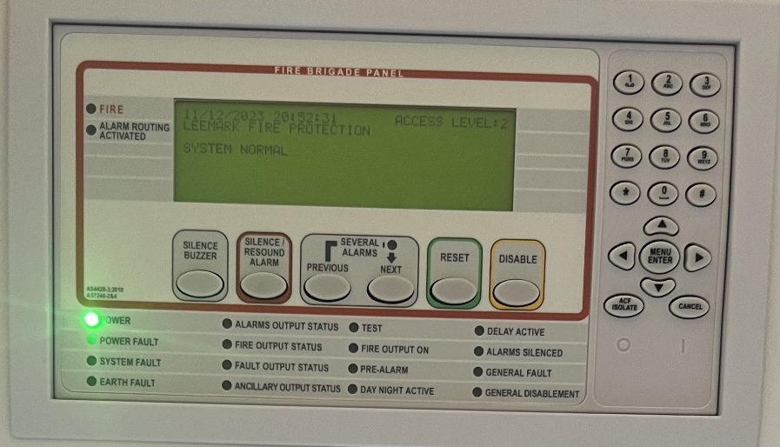

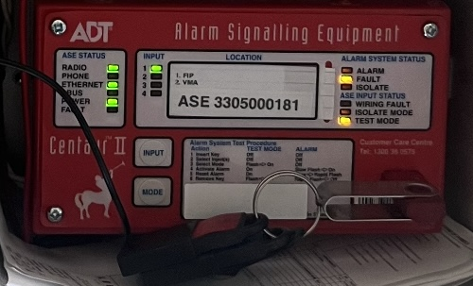

**DO NOT PRESS ANYTHING IF THERE ARE RED LIGHTS -** Proceed with evacuation procedure.